Nama : Brevalda Resnu Putra Kaltanda

Nrp : 218180412

Jurusan : S1-Sistem Informasi Bisnis

**Background:**

Every company undoubtedly wants its business to grow. Collaboration between companies, or multi-company setups, is becoming an increasingly dominant trend. However, this type of business relationship is often overshadowed by trust issues, particularly concerning expenses.

**Objective:**

This website aims to identify and record expenses, which are the primary factors that lead to trust issues in the financial aspects of companies operating under a multi-company scheme. In addition, the website also seeks to explore these trust issues in relation to the strategic and operational financial decisions made by the companies.

**Features:**

*Transaction Recorder:*

1. Employee Salaries
2. Account Records
3. Future Records
4. Project Operational Costs
5. Personal Expenses
6. Miscellaneous Expenses
7. Non-budgeted Operational Costs
8. Operational Reports
9. Project Operational Reports
10. Personal Expense Reports
11. Miscellaneous Expense Reports
12. Overall Reports

*Approval:*

1. Project Expense Approval
2. Personal Expense Approval
3. Project Budgeting

*Admin:* Includes everything in Approval and Transaction Recorder, plus:

1. Registration
2. Company Management

**Analysis:**

The image below shows the results of a trial that has been conducted. There were 6 respondents in this trial, consisting of 3 people working in the field and 3 general users. The image shows the satisfaction level in using this website from the perspectives of transaction recorders, the approval team, and admins. Five respondents found the website helpful and gave it a 5-star rating, while one respondent gave it a 4-star rating. Additionally, four respondents were satisfied with the website and gave it a 5-star rating, while two others gave it a 4-star rating.

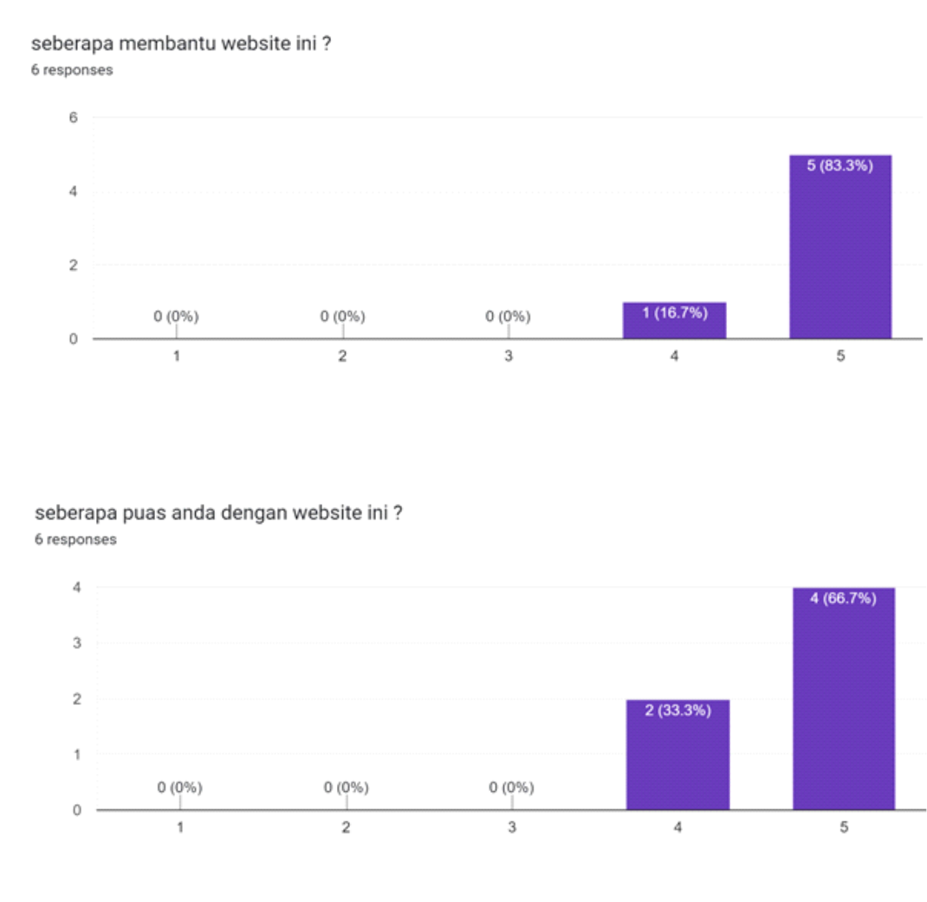

**Conclusion:**

This website can assist users, especially companies with a multi-company structure. However, it can also function well for businesses with branches or even non-profit organizations with one or more other departments.